INS3121
November 17, 2017

Group 4: Assoc . Prof. Dr. Pelin Özener
Group 5: Asst. Prof. Dr. Nejat N. Çetinkaya
SOIL MECHANICS
MIDTERM I
Q.1/20p | Q.2/20p | Q.3/20p | Q.4/20p | Q.5/20p | TOTAL
Name and Surname:
Number:
Group:

- a) Explain Atterberg Limits and the experiments that are used to determine Atterberg Limits. What is the importance of Atterberg Limits in engineering purpose? Explain briefly (4p).

b) Explain the terms of uniform soil and well-graded soil (4p).

c) What is capillarity? What is its importance in Civil Engineering? (4p).

- Explain the terms discharge velocity and seepage velocity and write the expression between them (4p).

- Which laboratory tests are used to determine permeability coefficient of the soils? Explain briefly their application with respect to soil type (4p).

- Classify the soils, for which the grain size distribution and consistency limits are given below, according to Unified Soil Classification System (USCS) and American Association of State Highway and Transportation Officials (AASHTO) Classification System. Which soil given below can be used in a core layer of an earth dam? (20p)
Soil A
Sieve No. | Percent finer (%) | Atterberg Limits
# 4 | 90 | LL = 45
# 10 | 78 | PL = 30
# 40 | 55
# 100 | 35 | Inorganic soil
# 200 | 14
D₁₀ | 0.09 mm
D₃₀ | 0.15 mm
D₆₀ | 0.5 mm
Soil B
Sieve No. | Percent finer (%) |  | Atterberg Limits
# 4 |  | 100 | LL = 68
#10 |  | 80 | PL = 57
#40 |  | 72
#100 |  | 61 | Inorganic soil
#200 |  | 55
D₁₀ |  | 0.002 mm
D₃₀ |  | 0.005 mm
D₆₀ |  | 0.15 mm

- For the experimental system shown below,
- Determine the pressure, elevation, and total head at points A, B, C, D, and E (15p).
- If the coefficient of permeability (k) for the soil is 0.04 cm/sec, compute the discharge velocity of water through the soil (the soil is located between points B and D) (5p).

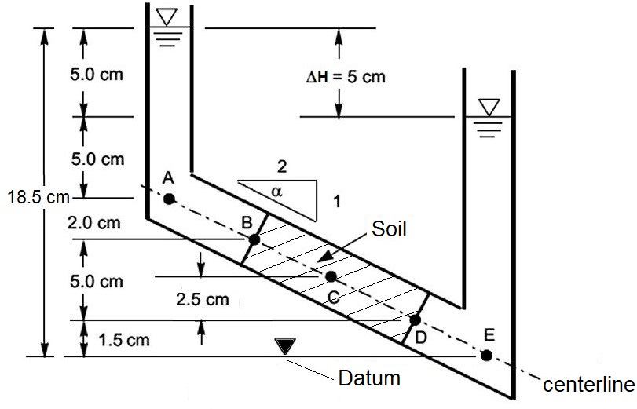

- A flow net under a concrete dam resting on a permeable soil is given in the figure. Saturated unit weight and permeability coefficient of the silty sand soil are 19 kN/m³ and 1.2x10⁻² cm/sec, respectively. Based on this information:
- Calculate the seepage loss under concrete dam per unit width (4p).
- Calculate the water uplift pressures and draw the water pressure distribution acting under the dam. (both points of A and F are the center points of the related equipotential lines) (12p).
- Determine whether there is a quick sand condition at the exit point of the concrete dam or not (4p).

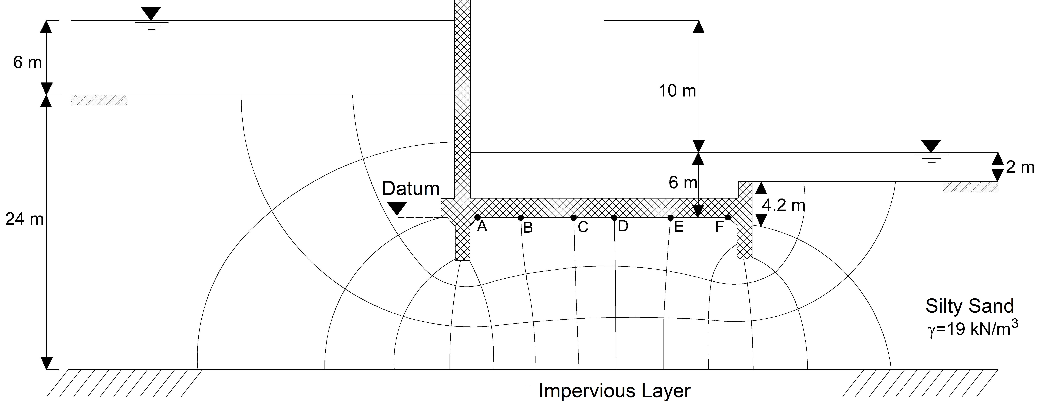

- For the given the soil profile below, compute the total vertical pressure, pore-water pressure, and effective vertical pressure at points A, B, C, D and draw the variations of these values with depth (20p).
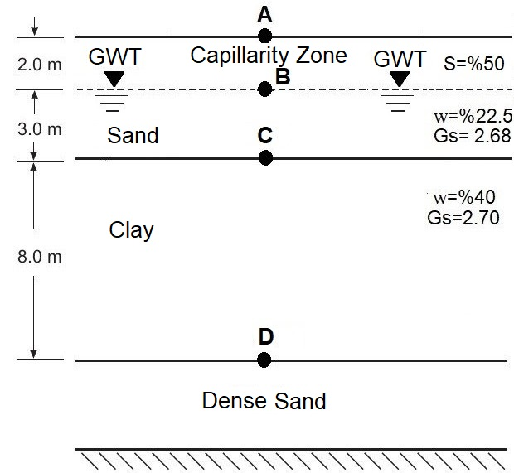

Time is 90 minutes. Good Luck…

